**MGT555- Innovation and Strategy**

**End-of-Course Assessment - January Semester 2023**

**Submission Deadline: Friday, 21 April 2023**

**Name:** Sruthi Madhusudanan

Table of Contents

Introduction 3

**Vision and Mission** 3

1a) Strategic tools and frameworks to conduct an internal and external environment analysis for UBTECH . 5

**Internal Environment analysis** 5

VRIO – UBTECH 5

Value chain analysis 6

**External Environment analysis** 7

PESTEL Framework 7

1b) Strategies that UBTECH employed to achieve significant success. 8

**Industry-leading proprietary tech stack driven by the commitment to R&D** 8

**Product line diversification and commercialization of products using proprietary technologies** 10

**Global partnership for global reach** 11

1c)Three new strategies for UBTECH to adopt to have continued success. 13

**Strategy 1** 13

Expanding into emerging markets 13

**Strategy 2** 14

Business expansion via acquisitions and investments 14

**Strategy 3** 15

Enhance R&D infrastructure to improve R&D capabilities and efficiencies 15

References 16

UBTECH

# Introduction

UBTECH is a globally recognized company that specializes in the design, development, and manufacturing of humanoid robots and AI .The company was founded in 2012 by Jian Zhou. UBTECH is a pioneer in the field of AI-empowered robotics, especially humanoid robots. They are a leader in the smart service robotics solutions covering R&D, Production, Commercialization & sales and marketing.

With its headquarters in Shenzhen, China, UBTECH has established a global presence, serving customers in over 160 countries. In 2018, UBTECH reached a value of $5 billion following the largest financing round ever completed for an artificial intelligence company, highlighting the company's technological leadership. (Advance, n.d.)

## **Vision and Mission**

Dream with robots. We believe that the future of human lies in human-robot co-existence. With an unwavering commitment to innovations and technology, we envisage to bring UBTECH robots to every home and industry, marching towards a society where human and robots co-exist.

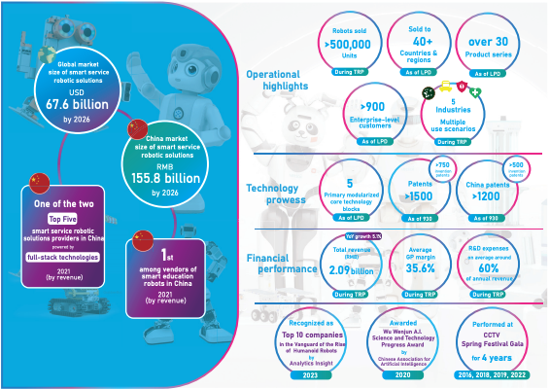

Figure 1: UBTECH Achievements

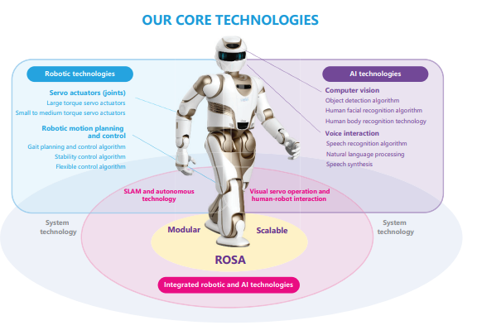

Figure 2 : UBTECH Core Technologies

The company's diverse portfolio includes consumer humanoid robots, enterprise service robots, and STEM skill-building robots for kids at home with JIMU Robot and in the classroom through UBTECH Education.

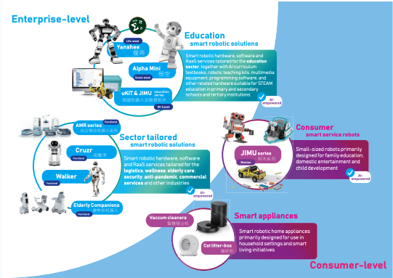

Figure 3 : Enterprise level Robots

# 1a) Strategic tools and frameworks to conduct an internal and external environment analysis for UBTECH .

## **Internal Environment analysis**

The strengths and weaknesses are established using internal analysis and refer to the variables inside an organisation that are within the short-run control of its senior management. We will be using VRIO & Value chain analysis to study the internal environment

### VRIO – UBTECH

|  |  |  |  |  |  |
| --- | --- | --- | --- | --- | --- |
| **Key resources and capabilities** | **Value** | **Rare** | **Inimitable** | **Organized** | **Competitive advantage** |
| **Strong focus on R&D and Innovation** | **Yes** | **Yes** | **Yes** | **Yes** |  |
| **Diversified product portfolio** | **Yes** | **Yes** | **No** | **Yes** |  |
| **Expertise in Robotics and AI technology** | **Yes** | **Yes** | **No** | **Yes** |  |
| **Patents** | **Yes** | **Yes** | **No** | **Yes** |  |
| **Strong brand recognition and reputation** | **Yes** | **No** | **No** | **Yes** |  |
| **Partnerships with leading tech companies** | **Yes** | **yes** | **No** | **Yes** |  |
| **Strong financial position** | **Yes** | **No** | **No** | **Yes** |  |

### Value chain analysis

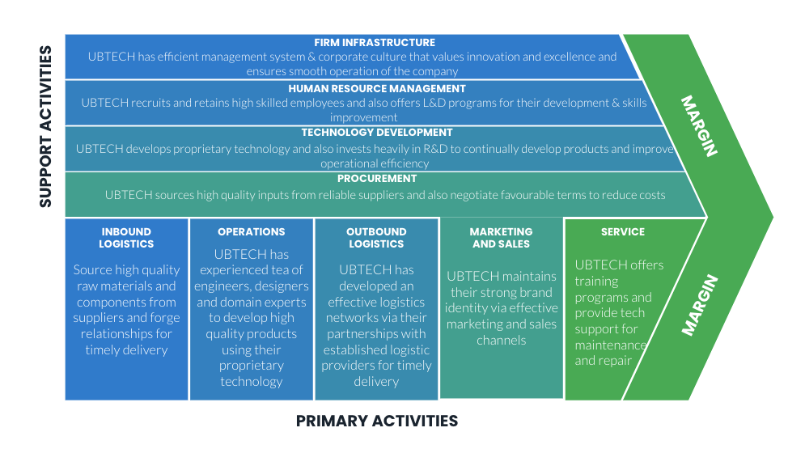

## **External Environment analysis**

### PESTEL Framework

External environment analysis helps identify opportunities and threats that are not typically within the short-run control of its senior management. We will be using the PESTEL framework.

**Political** - Robotics is an industry subject to government regulations. Maintaining compliance in all the countries they operate is critical. In China, where the company is headquartered, the government has been promoting the adoption of robotics through various plans like Made in China 2025. However, UBTECH also needs to comply with regulations in other countries like GDPR, PDPA etc.

**Economic -**  Fluctuations in the global economy can have an impact on the demand of robotic products. Economic situations directly impact the cost of labour and material which in turn impacts company’s growth and profitability. In recent years, there is widespread adoption of robotics due to the growth of automation technologies & AI.

**Social -** As UBTECH operates in multiple countries, changing demographics and consumer preferences between countries will have an impact on the demand of the products. UBTECH needs to understand its target market and customers and develop products that cater to them. As their primary market is China, products that are targeted for Chinese customers may not work as expected across other countries and needs customisation. Adding to it , the challenge in sustaining a high skilled workforce in the operating countries is also critical for long term success.

**Technology** - UBTECH invests heavily in R&D to stay ahead of its competitors. They must continue investing in new technologies to maintain competitive advantage. Especially with AI & ML technologies growing with applications like generative AI, UBTECH needs to constantly innovate to stay ahead of the curve. UBTECH in particular has been developing proprietary AI & ML technology for improving the functionality of their robots. Automation is at the heart of robotics. That is another area where UBTECH will constantly need to iterate to maintain their pole position.

**Environmental -** Complying with environmental regulations is another major challenge for UBTECH. Sustainable development has been one of most discussed topics globally in the second half of the last decade. UBTECH needs to adopt sustainable development practices in order to minimise the impact on the environment. In particular, UBTECH must be aware of their manufacturing process which can generate waste and has high energy consumption.

**Legal -** UBTECH relies on its intellectual property(IP) to maintain their competitive advantage. IP infringement is one of the major challenges the companies face. The company must ensure that it has appropriate policies in place and must enforce its IP rights whenever necessary. In particular, the company has faced legal disputes over IP in the past and they must stay vigilant.

# 1b) Strategies that UBTECH employed to achieve significant success.

Since their inception in 2012, UBTECH has grown to become a major market player in China’s smart service robotic solutions industry providing AI-empowered service robots and robotic solutions to enterprise-level and consumer-level customers. Let's have a look at some of their strategies that has enabled them to achieve this unprecedented success.

## **Industry-leading proprietary tech stack driven by the commitment to R&D**

One of the primary contributors to the success of UBTECH has been due to their focus on the development of proprietary technologies and their unrelenting commitment to R&D. Since their establishment in 2012, UBTECH has grown rapidly to establish themselves as an Industry leader in the smart service robotics industry. UBTECH is one of the few companies in the world that simultaneously masters and fully integrates core technologies and algorithms such as robot servo drives, motion control, artificial intelligence perception, robot positioning, and navigation.UBTECH has self-developed their own proprietary robotic and AI technologies, some of which includes servo actuators, robotic motion planning and control, SLAM and autonomous technology and visual servo operation and human-robot interaction. These technologies enable UBTECH’s smart service robots to be flexible and perform diverse and precise movements. They also enable the robots to perceive the surrounding environment and adapt to it, and enhance people interaction. The innovation of Walker X, life sized humanoid robots, which stands at the intersection of the latest robotic and AI technologies serves as a testament to UBTECH’s R&D capabilities and their unwavering commitment to R&D.

UBTECH has expended significant resources on R&D, employing a total of 736 R&D team which includes undergrads, postgrads and doctorates. UBTECH’s R&D commitment can be seen from the fact that they have spent RMB428.8 million, RMB517.1 million, and RMB324.7 million in FY2020, FY2021, and 9M2022, respectively, accounting for approximately 57.9%, 63.3%, and 61.4% of our total revenue during the respective periods. UBTECH has successfully commercialized more than 20 types of smart serviced robots using their proprietary robotic and AI technologies. UBTECH’s unrelenting commitment towards R&D has been recognized by major awards and recognitions, including the "First Prize of Science and Technology Progress of Guangdong Province in 2021," "WAIC2021 — Pioneer Award," "Outstanding Partner of World Robot Conference," "AI Tianma-Leadership," "Top 10 Robotics Companies that will Gain More Prominence in 2022," and "Service Robot Product Innovation Award."

With the smart service robots industry growing, UBTECH is well positioned to ride the wave and take advantage of the demand for customized and high quality smart robotic products and solutions in the market using their well advanced proprietary technology and R&D.

## **Product line diversification and commercialization of products using proprietary technologies**

Another strategy which has helped UBTECH achieve success over the years is diversification and commercialization of products across various industries. UBTECH boasts a diverse range of AI-empowered robotic solutions across various industries including education, logistics, general service, and wellness and elderly care. With a portfolio of more than 50 types of products, UBTECH sold over 500,000 units of robotic products for different use scenarios in different sectors. UBTECH’s products and solutions are designed to streamline operations, improve efficiency, and reduce costs while creating a safer and more productive environment for businesses.

**Education** : UBITECH is a pioneer and leader in the education sector for smart robots. Since 2017, UBITECH has developed inspiring AI curriculum materials and robotic products throughout the K-12 education curriculum to encourage students to embrace robotic and AI technologies.UBITECH’s education products and solutions aim to create an engaging learning environment for students and give them hands-on experience by providing well-structured course materials and a wide variety of robotic products combined with robot software. According to Frost & Sullivan, in 2021, UBITECH ranked first in China and accounted for approximately 20.1% of the education smart service robotic solutions industry by revenue. As of September 30, 2022, UBITECH’s product lines of education smart service robotic solutions industry consisted of more than 60 types of products, and they had successfully built up business relationships with numerous government educational institutions.

**Logistics :** Leveraging their R&D and commercialization capabilities from the education sector, UBITECH in FY2020 launched logistics smart robotic products and solutions, including AGVs/AMRs and automated storage and retrieval systems (AS/RS). UBITECH’s logistics products and solutions help enterprises automate and intellectualize cargo movements, streamline operation flow, provides intelligence to warehouse storage, distribution as well as manufacturing process which inturn reduces cost and improves operational efficiency.Since the launch of our logistics smart robotic products and solutions, UBITECH recorded significant growth in revenue, from RMB12.7 million in FY2020 to RMB190.8 million in FY2021, representing an increase of 1402.4%. UBITECH’s revenue from this segment remained relatively stable at RMB52.4 million and RMB51.0 million in 2021 and 2022, respectively.

**General service robots :** UBITECH offers wide range of general service robots, like inspection robots which can be deployed in transportation hubs, commercial buildings, outdoor environments to name a few.UBITECH’s general service smart robots sales increased from RMB36.3 million in FY2020 to RMB77.4 million in FY2021, contributing an increase of 113.2%, primarily due to the increase in demand since 2020 related to anti-pandemic measures amidst the outbreak of COVID-19. Anti-pandemic model of Cruzr and the anti-pandemic model of AIMBOT were some of the new robots launched.

**Wellness and elderly care :** UBTECH launched wellness solutions in 2022 including (a) PathFynder, a smart wheelchair robot; (b) Welli, a smart companion robot; and (c) a wellness and elderly care smart cloud-based platform, a centralized system for overall management of operations and service provisions. UBTECH’s well solutions aim to address the challenges faced by elder care facilities. During the second half of 2022, UBTECH has received over 30 enquiries from potential customers.

**Consumer robots and other smart devices :** UBTECH aims to bring their education, logistics, general services, and wellness solutions to every home by launching consumer-level robots and smart hardware devices. Some of their user-friendly products include the Alpha Mini humanoid, smart cat litter box, and AiRROBO smart vacuum cleaner, which provide convenience and increase efficiency for household chores.

## **Global partnership for global reach**

UBTECH is a China based smart robot company with a global footprint. UBTECH over the years have forged value partnerships with different companies across different industries to expand their market presence. We have partnered with global industry leaders such as a US-based smartphone, tablet, and computer manufacturer, a US-based e-commerce retailer, a US-based mass media and entertainment conglomerate, and a Chinese multinational technology and entertainment conglomerate to launch various robotic products and solutions. UBTECH’s strategic partnerships with industry leaders help them broaden revenue sources, provide marketing and brand recognition, while also helping them improve their products. UBTECH leverages its strategic partnerships and tap on their partner’s brand and reputation and serves as a successful model for partnerships with other market leaders moving forward. Along with this , UBTECH also participate in major events to increase their brand awareness, such as the CCTV Spring Festival Gala and the Beijing Winter Olympic Games, and has been appointed as the sole official AI-robotics partner in the China Pavilion of Dubai World Expo.

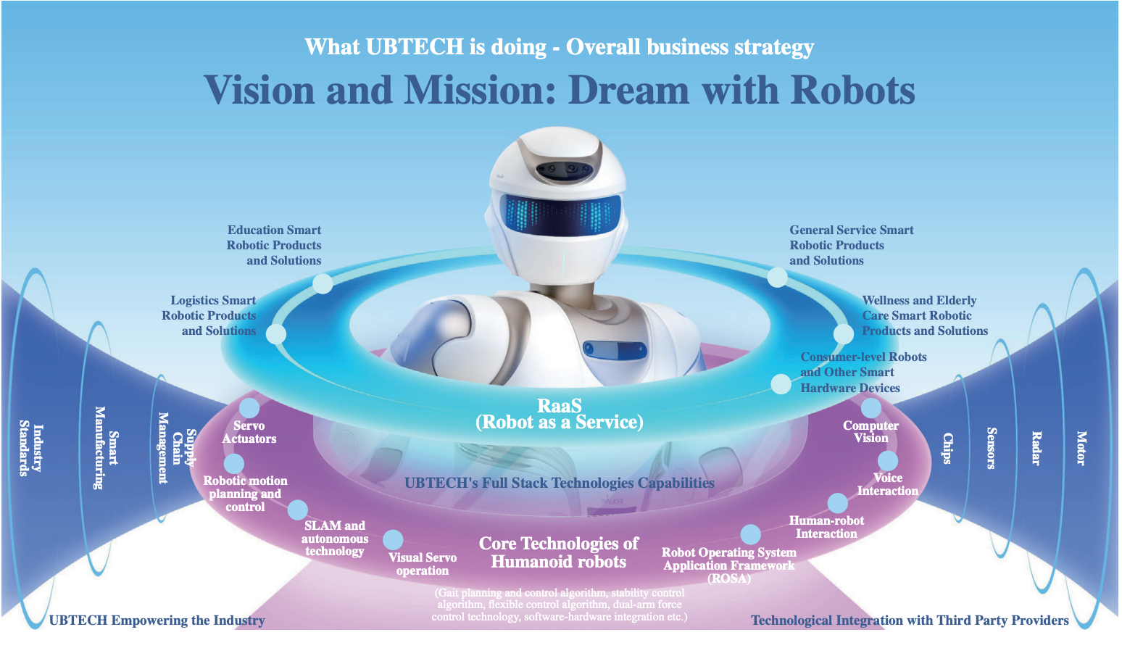

Figure 4 : Business strategy

# 1c)Three new strategies for UBTECH to adopt to have continued success.

## **Strategy 1**

### Expanding into emerging markets

One potential strategy for UBTECH to have continued success is to focus on emerging markets particularly in Asia, Africa, and Latin America and develop products catering to these markets. According to the World Economic Forum's "The Future of Jobs Report 2020”, these regions are expected to witness a significant growth in demand for robotics over the next decade. The report also noted that China, India and Indonesia are expected to have increased demand for robots by over 20% annually. As per Statista 2021 report, the global robotics market is expected to be $275.9 billion by 2025.

According to the International Federation of Robotics, Asia has been the largest robotics market since 2013 and its still on the rise. Asia accounts for 67% of global sales of industrial robots. Service robots is another emerging trend across Asia, particularly in Japan, China and South Korea with a projected annual growth rate of 25% from 2020-2025. Africa is another emerging market with growth opportunities in agriculture, healthcare and education. To encourage development and adoption of robots, African union has launched the African union robotics program. In Latin America, especially in Brazil and Mexico there is a strong demand for automation across industries such as automotive manufacturing and healthcare. There is a growing demand for service robots in this region especially for cleaning and security.

To develop products for emerging markets is a tricky challenge. For such markets disposing income is limited and cost effective solutions should be the order of the day. To tackle this, UBITECH could form partnerships with local companies to better understand the local demographics and consumer preferences in these regions. Having such an approach would help UBITECH tailor its products to suits the needs of the emerging markets and customers in the region. This in turn can lead to higher market penetration and adoption.

By investing in these emerging markets UBITECH can tap into the needs of the growing market and also establish a strong brand presence in these regions. This approach sets the company up for long term success by creating new opportunities and expanding their market reach.

## **Strategy 2**

### Business expansion via acquisitions and investments

Another strategy that UBITECH could consider to strengthen their position as market leaders in smart robotics products and solutions is via acquisition and investments. This approach allows UBTECH to gain access to new technologies, shorten their R&D process, expand their use cases and penetrate into new markets. UBTECH can look for potential targets that could enhance their core technologies in humanoid robots.

To set them up for access in this strategy, UBTECH should look for target companies that possess AI or robotic technologies that they don't have yet , so that it will be aligned towards their goal of shortening their R&D efforts and also improving market penetration. Additionally UBITECH could also look at potential targets in their upstream raw material supply as it could enhance their overall business performance and operational efficiency.

According to a report by ResearchAndMarkets.com, the global humanoid robot market is expected to grow at a CAGR of 40.5% from 2021 to 2028. By focussing on the acquisition strategy and investing in companies that possess cutting-edge technologies, UBITECH will be well positioned to further enhance their market share and competitive advantage. This strategy is also well in line with the overall M&A trend in the robotics industry which has considerably increased in recent years. According to a report by Deloitte, M&A activity in the robotics industry reached a record high in 2018, with a total of 267 deals worth $16.8 billion.

In conclusion, UBTECH's business expansion strategy of acquisitions and investments can help the company maintain its competitive edge in the smart robotics industry, enter new markets, and capitalize on the significant growth potential in the global humanoid robot market.

## **Strategy 3**

### Enhance R&D infrastructure to improve R&D capabilities and efficiencies

Another potential strategy is to upgrade the R&D infrastructure to improve R&D capabilities and efficiencies. This improvement will facilitate UBTECH to undertake technological innovation and enable the development of core technologies, products, and solutions that meet the latest technological developments and customer needs. To achieve this goal, UBTECH could acquire machinery, equipment, and software and recruit R&D personnel for the existing R&D laboratories located at the R&D institute in Shenzhen which include 6 different labs.

By enhancing the capabilities and efficiencies of these labs UBTECH will be able to sustain the ongoing refinement of its core technologies, algorithms, hardware, and software platforms. This will help the company maintain its leading position in the smart service robotic solutions industry by enabling it to develop innovative products and solutions that meet customer needs and the latest technological developments. Overall, this strategy is aimed at ensuring the long-term success and growth of the company by investing in its R&D capabilities and infrastructure.

# References

UBTECH. (n.d.). Application Proof of UBTECH ROBOTICS CORP LTD. Retrieved from https://www1.hkexnews.hk/app/sehk/2023/105125/documents/sehk23013101155.pdf

official, W. (n.d.). Retrieved from UBTECH: https://www.ubtrobot.com/

Markets, R. a. (October , 2022). Global Humanoid Robot Market, By Component, By Application, By Motion Type, By Region- Forecast and Analysis 2022-2028. Retrieved from https://www.researchandmarkets.com/reports/5675588/global-humanoid-robot-market-by-component-by

Delloite. (September , 2019). Retrieved from Number of organisations scaling automation doubles in 2019: https://www2.deloitte.com/uk/en/pages/press-releases/articles/number-of-organisations-scaling-automation-doubles-in-2019.html

Forum, W. E. (October , 2020). The Future of Jobs Report 2020. Retrieved from https://www.weforum.org/reports/the-future-of-jobs-report-2020

Statista, M. P. (April, 2022). Retrieved from Revenue of mobile robots worldwide from 2018 to 2025, by industry(in million U.S. dollars): https://www.statista.com/statistics/1283755/mobile-robots-revenue-worldwide-industry/

Yang, L. (August , 2016). Retrieved from Inside A Chinese Entrepreneur's Robot Dream: https://www.forbes.com/sites/linyang/2016/08/17/inside-a-chinese-entrepreneurs-robot-dream/?sh=27723d52f76f

Brewster, T. (August, 2017). Retrieved from Prepare To Be Terrified -- Watch A Hacked Robot Stab A Tomato With A Screwdriver: https://www.forbes.com/sites/thomasbrewster/2017/08/22/hacked-home-robot-gets-stabby-with-screwdriver/?sh=7627fbb7707a